Name: Ling Siew Tin Janice
Tasks
Task 1: Data Pipeline Construction (with mandatory logging)
Build a Python script named pipeline.py that performs the following tasks:
- Load the raw CSV file
  - Load the raw CSV using appropriate file-handling techniques.
  - Use exception handling with try/except to handle file I/O and parsing errors.
  - Do not use a bare except: statement.

Script:
import logging
import pandas as pd

# ---------------------------------------------------------
# Configure logging
# ---------------------------------------------------------
logging.basicConfig(
level=logging.INFO,
format="%(asctime)s - %(levelname)s - %(message)s"
)

# ---------------------------------------------------------
# Load raw CSV with proper exception handling
# ---------------------------------------------------------
def load_raw_csv(file_path: str) -> pd.DataFrame:
"""
Load the raw CSV file with logging and safe exception handling.
"""
logging.info(f"Attempting to load CSV file: {file_path}")

try:
df = pd.read_csv(file_path)
logging.info(f"CSV loaded successfully. Shape: {df.shape}")
return df

except FileNotFoundError as e:
logging.error(f"File not found: {file_path}")
raise e

except pd.errors.ParserError as e:
logging.error(f"CSV parsing error: {e}")
raise e

except Exception as e:
logging.error(f"Unexpected error occurred: {e}")
raise e

# ---------------------------------------------------------
# Main pipeline entry point
# ---------------------------------------------------------
if __name__ == "__main__":
logging.info("Starting data pipeline...")

raw_file = "Metro_Interstate_Traffic_Volume.csv"

df = load_raw_csv(raw_file)

logging.info("Pipeline completed successfully.")

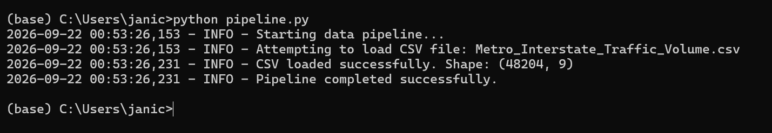

- Validate the data schema
  - Validate the schema before performing any other data-processing operations.
  - Check that all expected columns are present in the dataset.

Script
import logging
import pandas as pd

# ---------------------------------------------------------
# Configure logging
# ---------------------------------------------------------
logging.basicConfig(
level=logging.INFO,
format="%(asctime)s - %(levelname)s - %(message)s"
)

# ---------------------------------------------------------
# Load raw CSV with proper exception handling
# ---------------------------------------------------------
def load_raw_csv(file_path: str) -> pd.DataFrame:
"""
Load the raw CSV file with logging and safe exception handling.
"""
logging.info(f"Attempting to load CSV file: {file_path}")

try:
df = pd.read_csv(file_path)
logging.info(f"CSV loaded successfully. Shape: {df.shape}")
return df

except FileNotFoundError as e:
logging.error(f"File not found: {file_path}")
raise e

except pd.errors.ParserError as e:
logging.error(f"CSV parsing error: {e}")
raise e

except Exception as e:
logging.error(f"Unexpected error occurred: {e}")
raise e

# ---------------------------------------------------------
# Validate data schema
# ---------------------------------------------------------
def validate_schema(df: pd.DataFrame, expected_columns: list) -> None:
"""
Validate that all expected columns are present in the dataset.
"""
logging.info("Validating data schema...")

missing_columns = [col for col in expected_columns if col not in df.columns]

if missing_columns:
logging.error(f"Schema validation failed. Missing columns: {missing_columns}")
raise ValueError(f"Missing columns in dataset: {missing_columns}")

logging.info("Schema validation successful. All expected columns are present.")

# ---------------------------------------------------------
# Main pipeline entry point
# ---------------------------------------------------------
if __name__ == "__main__":
logging.info("Starting data pipeline...")

raw_file = "Metro_Interstate_Traffic_Volume.csv"

df = load_raw_csv(raw_file)

expected_columns = [
"holiday",
"temp",
"rain_1h",
"snow_1h",
"clouds_all",
"weather_main",
"weather_description",
"date_time",
"traffic_volume"
]

validate_schema(df, expected_columns)

logging.info("Pipeline completed successfully.")

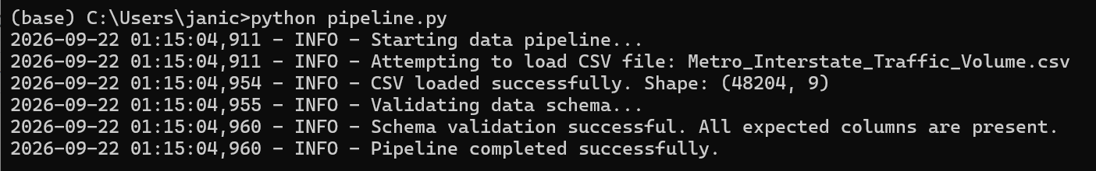

- Clean the data
  - Standardise inconsistent categorical values.
  - Parse and validate date/time fields.
  - Identify and remove duplicate rows.
  - Detect and handle outliers or impossible values.
  - For example, identify sensor readings showing 0 Kelvin or rainfall values exceeding the physically plausible range of 9K mm.
  - Impute identified outliers using the median where appropriate.

Script
# ---------------------------------------------------------
# Clean the data # ---------------------------------------------------------
def clean_data(df: pd.DataFrame) -> pd.DataFrame:
"""
Clean the dataset by standardising categories, parsing dates, removing duplicates, detecting outliers, and imputing values.
"""
logging.info("Starting data cleaning...")

# -----------------------------------------------------
# 1. Standardise inconsistent categorical values
# -----------------------------------------------------
logging.info("Standardising categorical values...")
df["weather_main"] = df["weather_main"].str.strip().str.lower()
df["weather_description"] = df["weather_description"].str.strip().str.lower() df["holiday"] =
df["holiday"].str.strip().str.lower()

# -----------------------------------------------------
# 2. Parse and validate date/time fields # -----------------------------------------------------
logging.info("Parsing date_time column...")
try:
df["date_time"] = pd.to_datetime(df["date_time"], errors="coerce")
except Exception as e:
logging.error(f"Error parsing date_time: {e}")
raise e

# Remove rows where date_time could not be parsed
invalid_dates = df["date_time"].isna().sum()
if invalid_dates > 0:
l ogging.warning(f"Removing {invalid_dates} rows with invalid date_time values.")
df = df.dropna(subset=["date_time"])

# -----------------------------------------------------
# 3. Remove duplicate rows
# -----------------------------------------------------
logging.info("Removing duplicate rows...")
before = len(df)
df = df.drop_duplicates()
after = len(df)
logging.info(f"Removed {before - after} duplicate rows.")

# -----------------------------------------------------
# 4. Detect impossible values (outliers)
# -----------------------------------------------------
logging.info("Detecting impossible sensor values...")

# Temperature: Kelvin cannot be 0
impossible_temp = df[df["temp"] <= 0].shape[0]
if impossible_temp > 0:
logging.warning(f"Found {impossible_temp} impossible temperature values (<= 0 Kelvin).")

# Rainfall: physically impossible > 9000 mm
impossible_rain = df[df["rain_1h"] > 9000].shape[0]
if impossible_rain > 0:
logging.warning(f"Found {impossible_rain} impossible rainfall values (> 9000 mm).")

# -----------------------------------------------------
# 5. Impute outliers using median
# -----------------------------------------------------
logging.info("Imputing outliers using median...")
temp_median = df[df["temp"] > 0]["temp"].median()
df.loc[df["temp"] <= 0, "temp"] = temp_median rain_median = df[df["rain_1h"] <= 9000]["rain_1h"].median()
df.loc[df["rain_1h"] > 9000, "rain_1h"] = rain_median

logging.info("Data cleaning completed successfully.")
return df

if __name__ == "__main__":
logging.info("Starting data pipeline...")

raw_file = "Metro_Interstate_Traffic_Volume.csv"

df = load_raw_csv(raw_file)
expected_columns = [
"holiday",
"temp",
"rain_1h",
"snow_1h",
"clouds_all",
"weather_main",
"weather_description",
"date_time",
"traffic_volume"
]

validate_schema(df, expected_columns)

df = clean_data(df)
logging.info(f"Data cleaning complete. Final shape: {df.shape}")

logging.info("Pipeline completed successfully.")

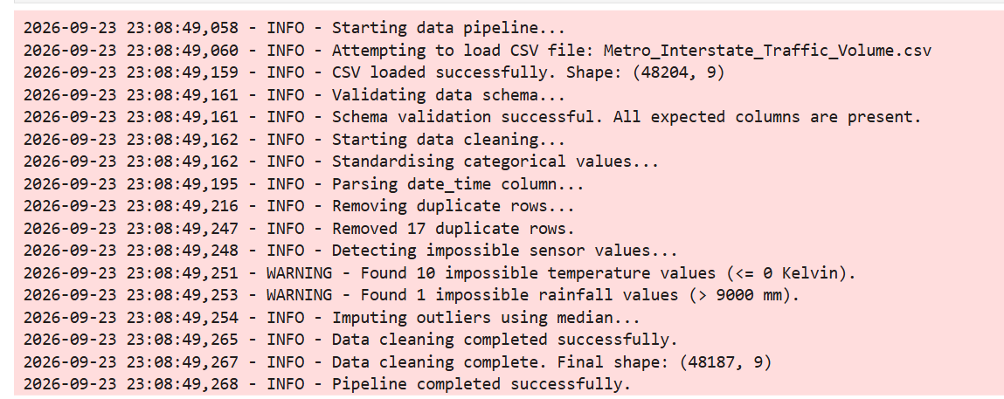

- Use conditionals and loops where appropriate
  - Use conditionals and loops explicitly when row-by-row or group-by-group processing is required.
  - For example, when imputing values by month, calculate and apply the appropriate monthly value rather than using a single global average for the entire dataset.
Script:
# ---------------------------------------------------------
# Clean the data with conditionals and loops (monthly imputation)
# ---------------------------------------------------------
def clean_data_with_monthly_imputation(df: pd.DataFrame) -> pd.DataFrame:
"""
Clean the dataset using conditionals and loops.
Impute outliers using monthly medians instead of global medians.
"""
logging.info("Starting advanced cleaning with monthly imputation...")

# Ensure date_time is parsed
df["date_time"] = pd.to_datetime(df["date_time"], errors="coerce")
df = df.dropna(subset=["date_time"])

# Extract month for group-by processing
df["month"] = df["date_time"].dt.month

# Loop through each month and apply monthly medians
for month in df["month"].unique():
logging.info(f"Processing month: {month}")

# Subset for the month
month_df = df[df["month"] == month]

# -----------------------------------------------------
# Temperature outliers (<= 0 Kelvin)
# -----------------------------------------------------
temp_outliers = month_df[month_df["temp"] <= 0].shape[0]
if temp_outliers > 0:
logging.warning(f"Month {month}: Found {temp_outliers} impossible temperature values.")

# Monthly median (only valid temps)
temp_median = month_df[month_df["temp"] > 0]["temp"].median()

# Apply imputation using conditionals
df.loc[(df["month"] == month) & (df["temp"] <= 0), "temp"] = temp_median

# -----------------------------------------------------
# Rainfall outliers (> 9000 mm)
# -----------------------------------------------------
rain_outliers = month_df[month_df["rain_1h"] > 9000].shape[0]
if rain_outliers > 0:
logging.warning(f"Month {month}: Found {rain_outliers} impossible rainfall values.")

# Monthly median (only valid rainfall)
rain_median = month_df[month_df["rain_1h"] <= 9000]["rain_1h"].median()

# Apply imputation using conditionals
df.loc[(df["month"] == month) & (df["rain_1h"] > 9000), "rain_1h"] = rain_median

logging.info("Monthly imputation completed successfully.")

# Remove helper column
df = df.drop(columns=["month"])

return df

df = clean_data(df)
df = clean_data_with_monthly_imputation(df)

logging.info(f"Advanced cleaning complete. Final shape: {df.shape}")

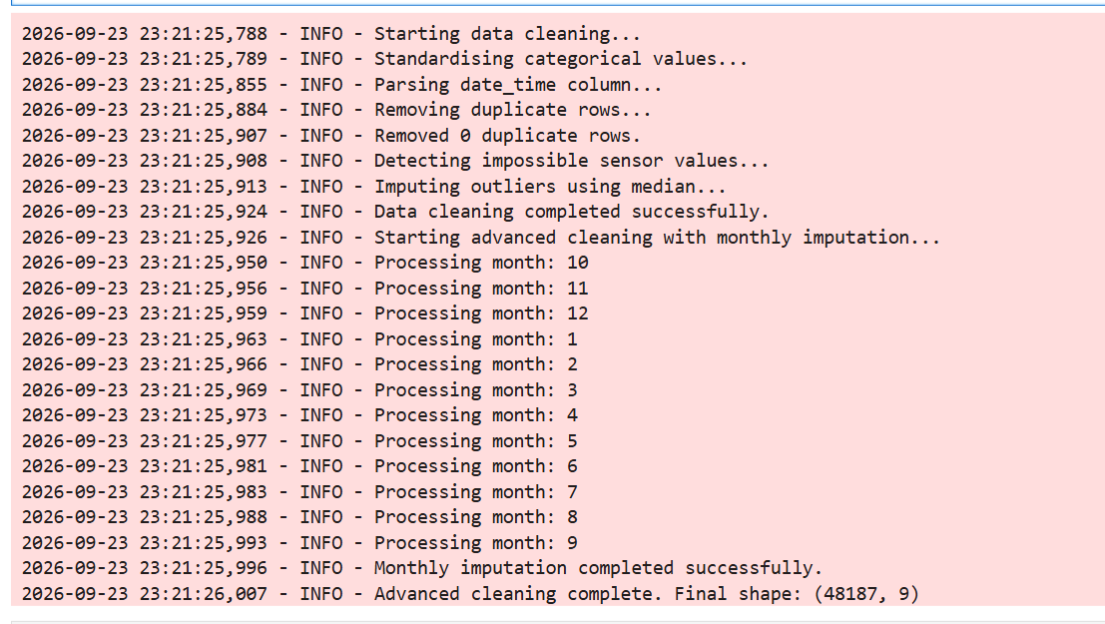

Task 2: Feature Engineering (NumPy and Pandas)
Using the cleaned dataset, create ML-ready features including:
Time features
- Hour
- Day of week
- Weekend indicator
- At least one cyclical encoding
Weather features
- Encode relevant categorical weather variables.
- Create appropriate derived weather indicators where useful.
Numerical features
- Create normalised/scaled versions of at least two continuous variables.
Traffic target
- Create a data-driven congestion category based on traffic volume.
- Document the logic used to create their target/category.

Script

def feature_engineering(df: pd.DataFrame) -> pd.DataFrame:
"""
Create ML-ready features:
- Time features (hour, day of week, weekend, cyclical encoding)
- Weather encodings
- Derived weather indicators
- Normalised/scaled numerical features
- Data-driven congestion category
"""

# Log dataset shape BEFORE feature engineering
logging.info(f"Feature Engineering START — Shape before: {df.shape[0]} rows, {df.shape[1]} columns")

# Ensure date_time is datetime (prevents .dt errors)
df["date_time"] = pd.to_datetime(df["date_time"], errors="coerce")
df = df.dropna(subset=["date_time"])

# -----------------------------------------------------
# TIME FEATURES
# -----------------------------------------------------
logging.info("Creating time-based features...")

df["hour"] = df["date_time"].dt.hour
df["day_of_week"] = df["date_time"].dt.dayofweek
df["is_weekend"] = df["day_of_week"].isin([5, 6]).astype(int)

# Cyclical encoding for hour
df["hour_sin"] = np.sin(2 * np.pi * df["hour"] / 24)
df["hour_cos"] = np.cos(2 * np.pi * df["hour"] / 24)

# -----------------------------------------------------
# WEATHER FEATURES
# -----------------------------------------------------
logging.info("Encoding weather features...")

# Encode categorical weather variable
df["weather_main_encoded"] = df["weather_main"].astype("category").cat.codes

# Derived indicators
df["is_rain"] = df["weather_main"].str.contains("rain").astype(int)
df["is_snow"] = df["weather_main"].str.contains("snow").astype(int)
df["is_cloudy"] = df["weather_main"].str.contains("cloud").astype(int)

# -----------------------------------------------------
# NUMERICAL FEATURES (Scaling)
# -----------------------------------------------------
logging.info("Scaling numerical features...")

# Min-max scaling for temperature
df["temp_scaled"] = (df["temp"] - df["temp"].min()) / (df["temp"].max() - df["temp"].min())

# Standard scaling for cloud cover
df["clouds_scaled"] = (df["clouds_all"] - df["clouds_all"].mean()) / df["clouds_all"].std()

# -----------------------------------------------------
# TRAFFIC TARGET (Data-driven congestion category)
# -----------------------------------------------------
logging.info("Creating congestion category...")

# Quartile thresholds — DEBUG only
q1 = df["traffic_volume"].quantile(0.33)
q2 = df["traffic_volume"].quantile(0.66)

logging.debug(f"DEBUG — Congestion thresholds: q1={q1}, q2={q2}")

def congestion_category(v):
if v < q1:
return "low"
elif v < q2:
return "medium"
else:
return "high"

df["congestion_category"] = df["traffic_volume"].apply(congestion_category)

# Log dataset shape AFTER feature engineering
logging.info(f"Feature Engineering END — Shape after: {df.shape[0]} rows, {df.shape[1]} columns")

logging.info("Feature engineering completed successfully.")
return df

import logging
logging.basicConfig(level=logging.INFO)

df = pd.read_csv("Metro_Interstate_Traffic_Volume.csv")

# Convert date_time BEFORE feature engineering
df["date_time"] = pd.to_datetime(df["date_time"], errors="coerce")
df = df.dropna(subset=["date_time"])

df = feature_engineering(df)
df.head()

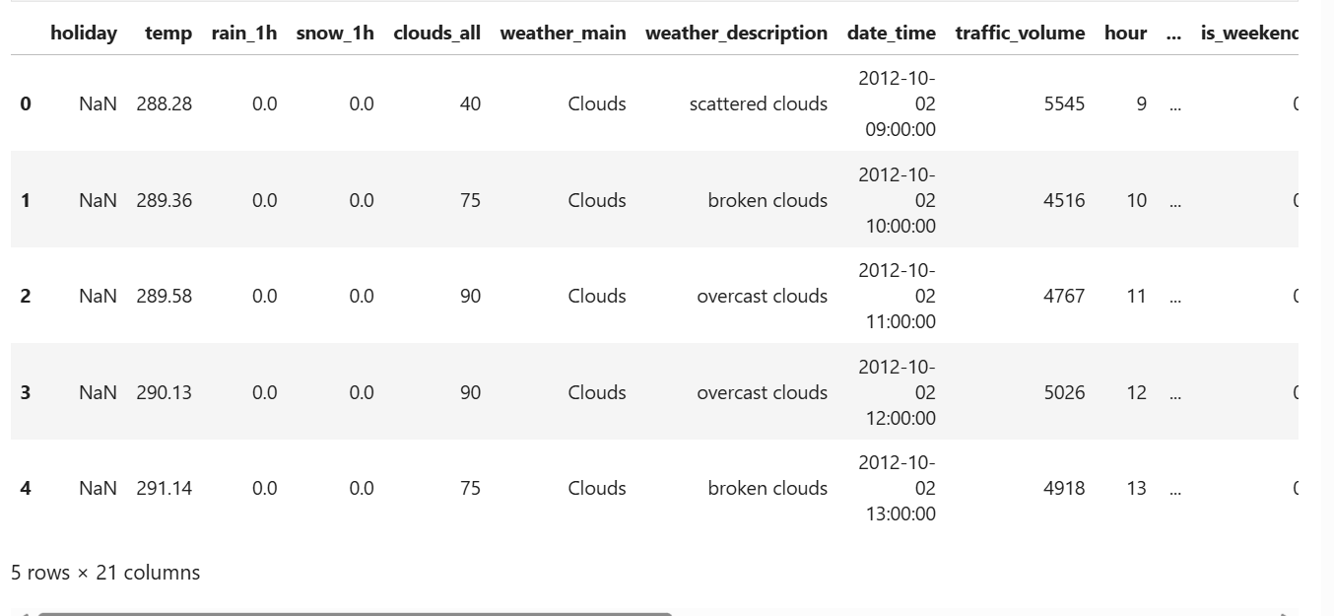

Task 3: Visualise Traffic Patterns
Create at least three Matplotlib visualisations that reveal meaningful patterns.
Examples include:
- Traffic demand by hour
- Weekday vs. weekend traffic
- Traffic and weather relationships
- Temperature vs. traffic
- Traffic distribution
- Congestion patterns over time
For each visualisation, provide a short interpretation.
Logging requirement:
Log an INFO message each time a figure is successfully saved, including its file path — this is your confirmation trail that all expected output files were produced.

Script
import pandas as pd
import numpy as np
import logging

logging.basicConfig(level=logging.INFO)

def feature_engineering(df: pd.DataFrame) -> pd.DataFrame:
logging.info(f"Feature Engineering START — Shape before: {df.shape}")

# Ensure datetime
df["date_time"] = pd.to_datetime(df["date_time"], errors="coerce")
df = df.dropna(subset=["date_time"])

# Time features
df["hour"] = df["date_time"].dt.hour
df["day_of_week"] = df["date_time"].dt.dayofweek
df["is_weekend"] = df["day_of_week"].isin([5, 6]).astype(int)

df["hour_sin"] = np.sin(2 * np.pi * df["hour"] / 24)
df["hour_cos"] = np.cos(2 * np.pi * df["hour"] / 24)

# Weather features
df["weather_main_encoded"] = df["weather_main"].astype("category").cat.codes
df["is_rain"] = df["weather_main"].str.contains("rain").astype(int)
df["is_snow"] = df["weather_main"].str.contains("snow").astype(int)
df["is_cloudy"] = df["weather_main"].str.contains("cloud").astype(int)

# Numerical scaling
df["temp_scaled"] = (df["temp"] - df["temp"].min()) / (df["temp"].max() - df["temp"].min())
df["clouds_scaled"] = (df["clouds_all"] - df["clouds_all"].mean()) / df["clouds_all"].std()

# Congestion category
q1 = df["traffic_volume"].quantile(0.33)
q2 = df["traffic_volume"].quantile(0.66)

def congestion_category(v):
if v < q1:
return "low"
elif v < q2:
return "medium"
else:
return "high"

df["congestion_category"] = df["traffic_volume"].apply(congestion_category)

logging.info(f"Feature Engineering END — Shape after: {df.shape}")
return df

import matplotlib.pyplot as plt

def visualise_traffic_patterns(df: pd.DataFrame):
if "hour" not in df.columns:
raise KeyError("Missing 'hour'. Run feature_engineering(df) first.")

if "is_weekend" not in df.columns:
raise KeyError("Missing 'is_weekend'. Run feature_engineering(df) first.")

# 1. Traffic by hour
hourly_avg = df.groupby("hour")["traffic_volume"].mean()

plt.figure(figsize=(10,5))
plt.plot(hourly_avg.index, hourly_avg.values, marker="o")
plt.title("Average Traffic Volume by Hour")
plt.xlabel("Hour")
plt.ylabel("Traffic Volume")
plt.grid(True)
plt.savefig("traffic_by_hour.png")
plt.close()
logging.info("Saved figure: traffic_by_hour.png")
print("Interpretation: Traffic peaks during morning and evening commute hours.")

# 2. Weekday vs Weekend
weekday_avg = df.groupby("is_weekend")["traffic_volume"].mean()

plt.figure(figsize=(8,5))
plt.bar(["Weekday", "Weekend"], weekday_avg.values)
plt.title("Weekday vs Weekend Traffic")
plt.ylabel("Traffic Volume")
plt.savefig("weekday_vs_weekend.png")
plt.close()
logging.info("Saved figure: weekday_vs_weekend.png")
print("Interpretation: Weekday traffic is higher due to commuting.")

# 3. Temperature vs Traffic
plt.figure(figsize=(10,5))
plt.scatter(df["temp"], df["traffic_volume"], alpha=0.3)
plt.title("Temperature vs Traffic Volume")
plt.xlabel("Temperature")
plt.ylabel("Traffic Volume")
plt.savefig("temperature_vs_traffic.png")
plt.close()
logging.info("Saved figure: temperature_vs_traffic.png")
print("Interpretation: Temperature has weak correlation with traffic volume.")

df = pd.read_csv("Metro_Interstate_Traffic_Volume.csv")

df["date_time"] = pd.to_datetime(df["date_time"], errors="coerce")
df = df.dropna(subset=["date_time"])

df = feature_engineering(df)

visualise_traffic_patterns(df)

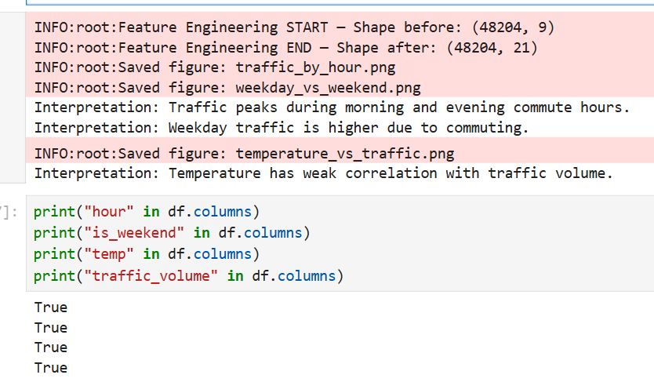

Task 4: Build a Mini Traffic Analytics Application
Develop a small command-line application that allows a user to query the processed dataset.
The application should support at least three different commands or queries.
For example:
- Query traffic for a specific date/time.
- Identify high-traffic periods.
- Compare weekday and weekend traffic.
- Identify recommended travel periods.
- Retrieve weather and traffic information.
Logging requirement
The application should log which command was invoked and with which arguments (INFO level) and should log a clear ERROR (rather than a raw traceback) if the user supplies invalid input, such as a malformed date.

Script
import logging
from datetime import datetime

logging.basicConfig(level=logging.INFO)

def run_traffic_app(df):
"""
Mini command-line traffic analytics application.
Supports multiple commands with logging and error handling.
"""

print("\n=== Mini Traffic Analytics Application ===")
print("Available commands:")
print("1. traffic_at <YYYY-MM-DD HH:MM>")
print("2. high_traffic_periods")
print("3. compare_weekday_weekend")
print("4. recommended_travel")
print("5. weather_traffic_at <YYYY-MM-DD HH:MM>")
print("Type 'exit' to quit.\n")

while True:
user_input = input("Enter command: ").strip()

if user_input.lower() == "exit":
print("Exiting application.")
break

# ---------------------------------------------------------
# COMMAND 1 — Query traffic for a specific date/time
# ---------------------------------------------------------
if user_input.startswith("traffic_at"):
try:
logging.info(f"Command invoked: {user_input}")

_, dt_str = user_input.split(" ", 1)

try:
dt = datetime.strptime(dt_str, "%Y-%m-%d %H:%M")
except ValueError:
logging.error("ERROR: Invalid date format. Use YYYY-MM-DD HH:MM")
print("Invalid date format. Use YYYY-MM-DD HH:MM")
continue

row = df[df["date_time"] == dt]

if row.empty:
print("No data found for that date/time.")
else:
vol = row.iloc[0]["traffic_volume"]
print(f"Traffic volume at {dt}: {vol}")

except Exception as e:
logging.error(f"ERROR: {str(e)}")
print("An error occurred. Please try again.")

# ---------------------------------------------------------
# COMMAND 2 — Identify high-traffic periods
# ---------------------------------------------------------
elif user_input == "high_traffic_periods":
logging.info("Command invoked: high_traffic_periods")

high = df[df["congestion_category"] == "high"]
result = high.groupby("hour")["traffic_volume"].mean().sort_values(ascending=False)

print("\nHigh Traffic Hours (sorted):")
print(result.head(10))

# ---------------------------------------------------------
# COMMAND 3 — Compare weekday vs weekend traffic
# ---------------------------------------------------------
elif user_input == "compare_weekday_weekend":
logging.info("Command invoked: compare_weekday_weekend")

weekday_avg = df[df["is_weekend"] == 0]["traffic_volume"].mean()
weekend_avg = df[df["is_weekend"] == 1]["traffic_volume"].mean()

print(f"\nAverage Weekday Traffic: {weekday_avg:.2f}")
print(f"Average Weekend Traffic: {weekend_avg:.2f}")

# ---------------------------------------------------------
# COMMAND 4 — Recommended travel periods (lowest traffic)
# ---------------------------------------------------------
elif user_input == "recommended_travel":
logging.info("Command invoked: recommended_travel")

low = df[df["congestion_category"] == "low"]
result = low.groupby("hour")["traffic_volume"].mean().sort_values()

print("\nRecommended Travel Hours (lowest traffic):")
print(result.head(10))

# ---------------------------------------------------------
# COMMAND 5 — Retrieve weather + traffic at a specific time
# ---------------------------------------------------------
elif user_input.startswith("weather_traffic_at"):
try:
logging.info(f"Command invoked: {user_input}")

_, dt_str = user_input.split(" ", 1)

try:
dt = datetime.strptime(dt_str, "%Y-%m-%d %H:%M")
except ValueError:
logging.error("ERROR: Invalid date format. Use YYYY-MM-DD HH:MM")
print("Invalid date format. Use YYYY-MM-DD HH:MM")
continue

row = df[df["date_time"] == dt]

if row.empty:
print("No data found for that date/time.")
else:
r = row.iloc[0]
print(f"\nWeather & Traffic at {dt}:")
print(f"Traffic Volume: {r['traffic_volume']}")
print(f"Weather: {r['weather_main']}")
print(f"Temperature: {r['temp']} K")
print(f"Cloud Cover: {r['clouds_all']}%")

except Exception as e:
logging.error(f"ERROR: {str(e)}")
print("An error occurred. Please try again.")

# ---------------------------------------------------------
# INVALID COMMAND
# ---------------------------------------------------------
else:
logging.error(f"ERROR: Unknown command '{user_input}'")
print("Unknown command. Please try again.")

df = feature_engineering(df)
run_traffic_app(df)

